

**Final Year Project Report**



**Development of a C++ based user-interface for a plasma simulation tool**



**Author: Zhang, Junming (ID: 201138928)**

**Project Supervisor: Dr.Mark Bowden**

**Project Assessor: Dr.Kirsty McKay**

**Department of Electrical Engineering and Electronics**

**28 April 2017**

**Declaration of academic integrity**

**I confirm that I have read and understood the University’s Academic Integrity Policy.**

**I confirm that I have acted honestly, ethically and professionally in conduct leading to assessment for the programme of study.**

**I confirm that I have not copied material from another source nor committed plagiarism nor fabricated, falsified or embellished data when completing the attached piece of work. I confirm that I have not copied material from another source, nor colluded with any other student in the preparation and production of this work.**

**SIGNATURE……………………………………………………………………………………… DATE ……………………………………………………………………………………….**

# Abstract

A powerful microplasmas simulation tool Plasimo will generate many output data in various formats. In order to make this tool widely accessible to industry users and plasma researchers, a user-friendly interface is needed to develop.

The generally developed procedure includes background research, prototype design, program development and program improvement.

This is a software only project and the implementation of this program is based on C++ Visual Studio.

After 20 weeks working, the Plasimo display assistant was built. Displaying each text file to corresponding propriety of plasma, generating 2D graphical images based on input data and creating line chart based on specific text file are 3 main functions of this program.

Contents

Abstract 2

1. Introduction 5

1.1 Background 5

1.2 Problem statements 8

2. Literature Review [5] 10

6.1 The web-based user interface for EAST plasma control system 10

6.2 Web interface for plasma analysis codes 11

6.3 User control interface for W7-X plasma operation 12

6.4 Literature reviews appendix 12

3. Theory 13

3.1 Developing flow path 13

3.2 Project Plan 13

4. Prototype Design 15

4.1 Tool 15

4.2 Design process 15

5. Program Development 19

5.1 Tools 19

5.1.1 Microsoft Visual Studio Community 2015 19

5.1.2 OpenGL 19

5.1.3 OpenCV 19

5.2 Analysis 19

5.2.1 Software requirements 19

5.3 Function Realization 20

5.3.1 User-interface building 20

3.2.2.2 3D graphical display function 20

3.2.2.3 Rapid loading text files function 20

6. Results 21

6.1 Interface installation 21

6.2 Interface demonstration 27

7. Industrial Relevance and Impact 38

8. Discussion 45

8.1 Interface testing 45

8.2 Project assessment 49

8.2 Addition exploitation 50

8.3 Difficulties 51

8.4 Future Improvements 52

9. Conclusion 53

References List 54

Appendices 56

Appendix 1. The specification report form 56

Appendix 2. A Gantt chart preferable produced by MS project 60

Appendix 3. The risk assessment form 61

Appendix 4. Ethical approval questionnaire 65

# Introduction

The objective of this project is to build a C++-based user interface for helping Plasma researchers obtain the simulated result more efficient. This interface would serve as an accessory program to process output data from the plasma simulation tool Plasimo.

## 1.1 Background

Plasma is the fourth fundamental state of matter which consists of neutral ions, electrons, photons and ions.

Figure 1 illustrates the general type of plasma which has the vacuum chamber, pump, gas flow system and electrodes.

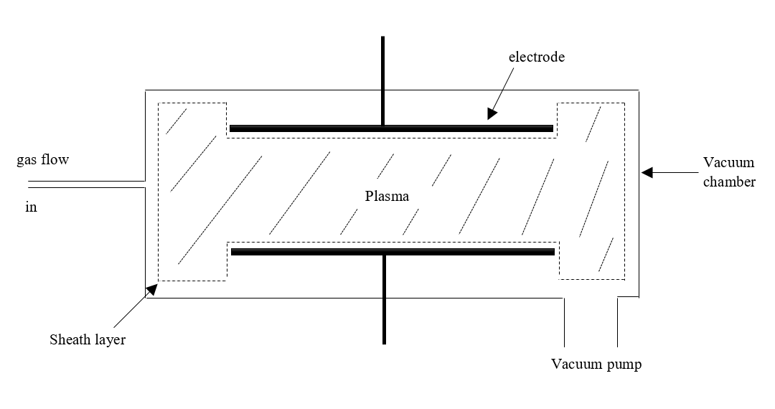

Figure 1. The general type of plasma structure

Plasimo is a powerful program to provide the transient and steady-state simulation of microplasma in different dimensional geometries [1].

Figure 2 shows the main window of Plasimo 5.0 developer version. Users could load different models of plasma to run the simulation. At the same time, observe the changing process and obtain the simulated result.

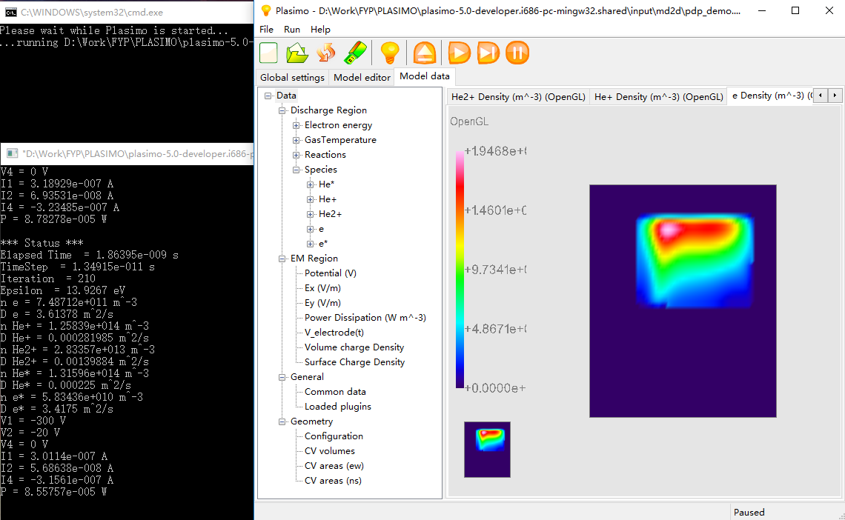

Figure 2. The main window of Plasimo developer 5.0 version

Supervisor Dr. Mark recommends the Micro Discharge 2D (pdp_md2d) for the target model in this project. It is a time- dependent model and the function of it is solving particle transport problem in conjunction [2].

Figure 3 displays the simulated result of the pdp_md2d model. Plasimo will generate 68 output files as “text” and “out” format in this case.

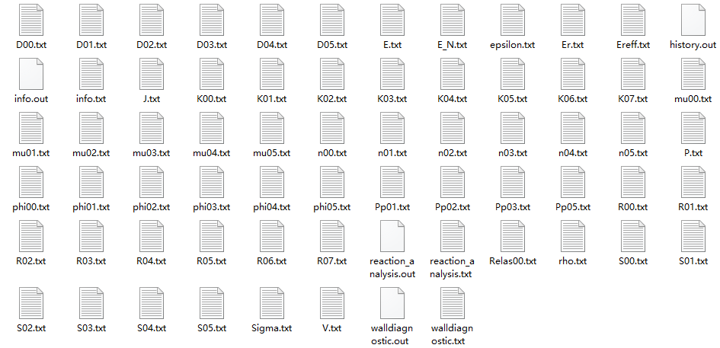

Figure 3. Simulated output files of pdp_md2d model

|  |  |
| --- | --- |
| n00.txt | electron energy density [J m-3] |
| phi00.txt | electron energy flux density [W m-2] |
| S00.txt | electron energy source [W m-3] |
| D00.txt | electron energy diffusion coefficient [W m2] |
| mu00.txt | electron energy mobility coefficient [J m2 V-1 s-1] |
| Relas00.txt | rate of electron energy loss from elastic collisions [W m-3] |
| epsilon.txt | mean electron energy [J] |
| n01.txt | density for species 1 [m-3] |
| S01.txt | source for species 1 [m-3 s-1] |
| D01.txt | diffusion for species 1 [m2 s-1] |
| mu01.txt | mobility for species 1 [m2 V-1 s-1] |
| phi01.txt | flux for species 1 [m-2 s-1] |
| R00.txt | reaction rate for reaction 1 [m-3 s-1] |
| K00.txt | reaction rate coefficient for reaction 1 [m3 s-1] |
| Pp01.txt | power dissipation for species 1 [W m-3] |
| P.txt | dissipated power density [W m-3] |
| J.txt | current density [C s-1 m-3] |
| V.txt | potential [V] |
| E.txt | electric field [V m-1] |
| Er.txt | reduced electric field E/p [V m-1 Pa-1] |
| E_N.txt | reduced electric field E/N [V m2] |
| rho.txt | volume charge density [C m-3] |
| sigma.txt | surface charge density [C m-2] |
| info.txt | the averaged values written with the user-specified frequency |
| info.out | the averaged values |
| history.out | gives the calculated variables as a function of time |

Table 1. The corresponding properties of output files [3].

Table 1 illustrates the corresponding plasma properties of output files and this table is obtained from the user guild of Plasimo.

## 1.2 Problem statements

As mentioned in the background section, Plasimo provides a simulated program to investigate different plasma models, however, there are some drawbacks of Plasimo:

* The numerical output data are saved in 68 different text files. Each one stores one specific propriety of plasma and their name is unreadable, users need the Table 1 in the Background section to find corresponding proprieties.
* Figure 2 shows that users can only observe one property at one time and they cannot obtain the simulated time and numerical data in this dialog box. Therefore, it is inconvenient for Plasimo user to do further research.

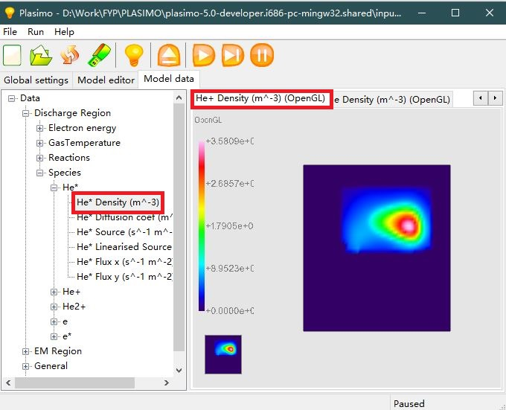

Figure 4. Simulation of pdp_md2d model

* The simulated process is irreversible and time-consuming. In this project, the pdp_md2d model usually cost 6 minutes to finish one simulation, if users want to observe 3 properties, they need 18 minutes. Moreover, some other models need 1 day to finish one simulation.
* A lot of output files was generated through the simulation of plasma. In pdp_md2d model, there are 68 output files which mean 68 different properties of plasma. However, some of these properties are helpless to users.

To solve these drawbacks, a user-friendly interface is needed to develop. Hence, the objective of this project is to build a suitable user-interface to help researchers and industry users obtain required output data effectively [4].

# 2. Literature Review [5]

## 6.1 The web-based user interface for EAST plasma control system

According to read the development part of EAST plasma control system, it could find that the interface design part is clearly because excellent workflows are used to express their ideas of function. Nonetheless, there still some drawbacks needed to avoid in this project by observing Figure 5, the intricate interface is unfriendly because this program needs to relieve time of users. Another is the narrow space between each button is unreadable.



Figure 5. The user interface of EAST plasma control system

## 6.2 Web interface for plasma analysis codes

Figure 6 shows the interface of plasma analysis code, all basic functions are display at one page include pictures, data, formulas and line charts. The concept of GUI design is worth to learn because users could observe the data when they do the simulation, however, all functions are displayed on one page is a complex design.



Figure 6. The Web interface for FIT code

## 6.3 User control interface for W7-X plasma operation

To reduce the workload of users is a significant concept from the design part of this control system. The function of the program should meet the requirements of users and tedious work should be finished by the program itself. Therefore, the user survey and the investigate of related software is an important step before start design.

## 6.4 Literature reviews appendix

* R.R. Zhang, B.J. Xiao, Q.P. Yuan, F. Yang, Y. Zhang, R.D. Johnson, B.G. Penaflor, " The web-based user interface for EAST plasma control system", *J. Appl. Phys.* February 2014, DOI: 10.1016/j.fusengdes.2014.02.07016
* M. Emoto, S. Murakami, M. Yoshida, H. Funaba and Y. Nagayama., " Web interface for plasma analysis codes", *J. Appl. Phys.* vol. 83, no.2-3, pp. 453-457, April 2008, DOI: 10.1016/j.fusengdes.2007.10.008
* S. Anett, L. Heike, S. Jörg, " User control interface for W7-X plasma operation", *J. Appl. Phys.* 2007, DOI: 10.1016/j.fusengdes.2007.05.052

# 3. Theory

## 3.1 Developing flow path

Step 1: Investigating objective of the project.

Step 2: Exchange ideas with supervisor.

Step 3: Analyse requirements of users.

Step 4: Propose basic functions of the program.

Step 5: Prototype design of program include interface and interaction.

Step 6: Slicing from prototype to build dialogs of the program.

Step 7: Program development based on the design.

Step 8: Program first demonstration and obtain suggestions.

Step 9: Program majorization and debug.

## 3.2 Project Plan

|  |  |
| --- | --- |
| **1) Preparatory Work** |  |
| 1.1) Obtain relevant tool and materials | Week 4 |
| **2) Research Work** |  |
| 2.1) Weekly background reading | Week 11 |
| 2.2) Literature review | Week 8 |
| 2.3) Learning Visual Studio, OpenGL | Week 16 |
| **3) Developing Work** |  |
| **3.1) Writing software requirements** |  |
| 3.1.1) Software Specifications | Week 8 |
| 3.1.2) Software analysis | Week 9 |
| **3.2) Design** |  |
| 3.2.1) Prototype design | Week 7 |
| 3.2.2) Main page developing | Week 7 |
| 3.2.3) Reading and Processing data function | Week 8 |
| 3.2.4) Menu developing | Week 9 |
| 3.2.5) Line chart function | Week 10 |
| 3.2.6) 2D graphic function | Week 16 |
| 3.3) Testing and Improving | Week 18 |
| 3.3.1) Program test and debug | Week 18 |
| **4) Presentation and Bench Inspection** |  |
| 4.1) Presentation preparation | Week 12 |
| 4.2) Project video | Week 18 |
| 4.3) Bench inspection speech draft and poster | Week 19 |
| **5) Report Work** |  |
| 5.1) Writing project specification form | Week 3 |
| 5.2) Writing preliminary report | Week 4 |
| 5.3) Weekly virtual log book | Week 18 |
| 5.4) Writing final report | Week 24 |

*The complete project plan will show in Appendix 2 with the new Gantt chart.*

# 4. Prototype Design

The prototype design is a significant step of design, the advantage of it is saving time in the program developing stage. It not just a simple draft on the paper, it equals to a simulated program because the dialog and widget were designed in this process. Moreover, the human-computer interaction and widget trigger were also built in this section. It supports an intuitionistic model to communicate with the supervisor. Therefore, the feedback can be given on the meeting and used to improve the design. Finally, the widget can be exported for real program development.

## 4.1 Tool

Mockplus is a practical prototype design tool. It is very easy to use because users can pull existed widgets to the mast page and set the respond command of them directly. In addition, this tool provides a bulk of elements and it can be displayed on the iPad and mobile phone.

## 4.2 Design process

An interface should give users a comfortable experience and easy to use. In the design process, it obeys the Eight Golden Rules of Interface design [10].

1. Strive for consistency
2. Cater to universal usability
3. Offer informative feedback
4. Design dialogs to yield closure
5. Prevent errors
6. Permit easy reversal of actions
7. Support internal locus of control
8. Reduce short-term memory load

The purpose of this interface is to let users observe the output data from Plasimo efficiently. Therefore, the theme of this design is concise and it should reduce the operation of users to decrease the learning cost.

Homepage design:

The homepage is the first view of the program and the new users are not familiar with it. Thus, a quick instruction should be displayed here and teach the user basic function and how to use it. In addition, there should have a help button to explain the outspread function and some common problems. The QR code is used to open the virtual log book of this project if users are interested in the developing process.

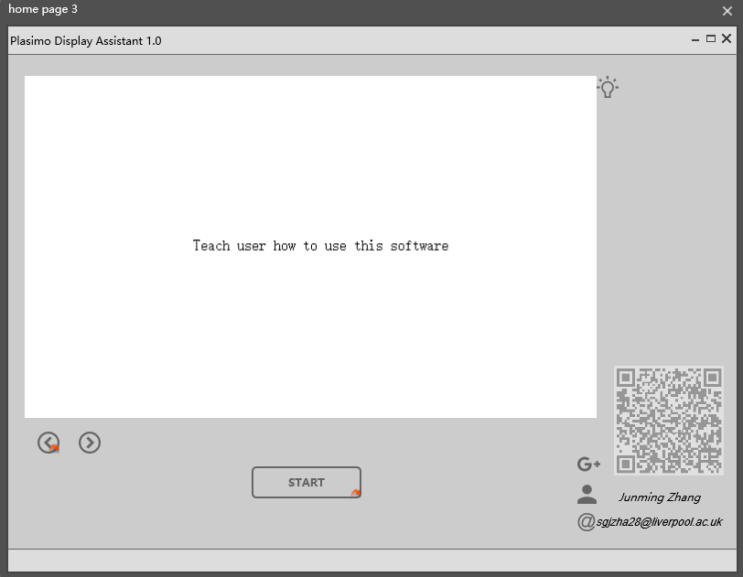

Figure 22. The home page of prototype design

Menu design:

The most basic plasma properties are [11]:

* Gas Density and pressure
* Neutral particle density
* Electron density
* Electron energy and electron temperature
* Ion density
* Plasma potential
* Ionization ratio

Lots properties of plasma bring a long menu, a custom menu could solve this problem, users could put the regular properties into the quick menu.

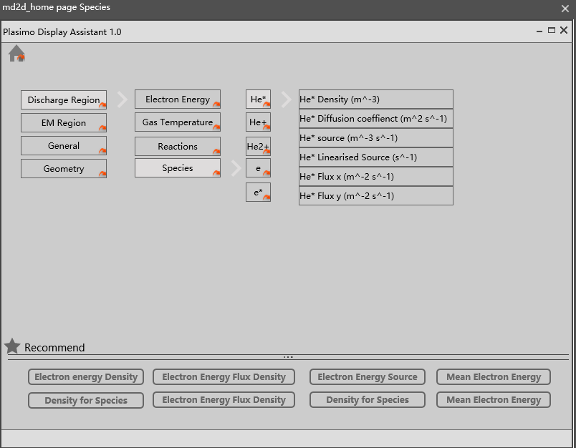

Figure 22. The menu of prototype design

Main window design:

According to the problem statement, users need to observe the changing process and numerical data at the same time, the main window should include these two part. One is the 2D graphical image based on output data, another is the numerical data display.

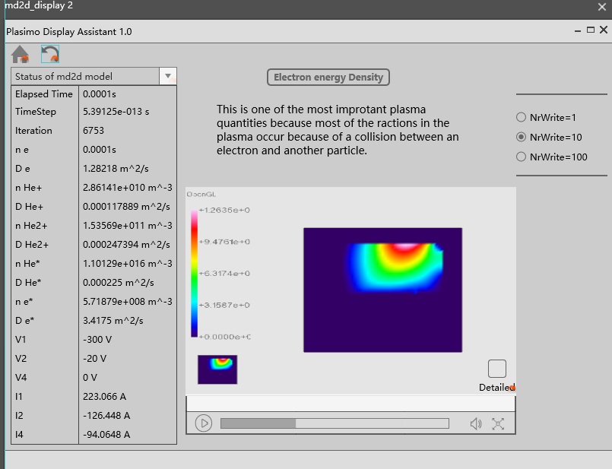

Figure 23. The main window of prototype design

# 5. Program Development

## 5.1 Tools

### 5.1.1 Microsoft Visual Studio Community 2015

Visual Studio is a fundamental program developing tool which could be applied on Windows platform. This project will use MFC in VS to build the frame of program and use Visual Studio to develop main function.

### 5.1.2 OpenGL

Open Graphics Library (OpenGL) is the most widely 2D and 3D Application Program Interface (API). It could be applied in lots of platforms such as Window, Linux and MacOS [12].

### 5.1.3 OpenCV

Open Source Computer Vision Library is based on C++ language which contains fundamental image process function. For example, image copy, input and output.

## 5.2 Analysis

### 5.2.1 Software requirements

The purpose of this interface is pre-processing the output data from the Plasimo. This program should be used to solve the problems where stated in the problem statements section. It could be summarized in Figure 24.

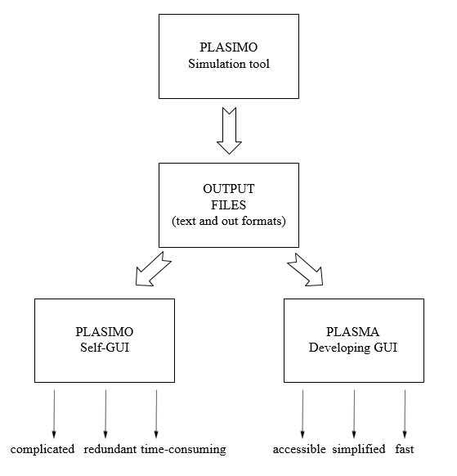

Figure 24. The summary of developing interface

### 5.2.2 Function specification

List of

## 5.3 Function Realization

### 5.3.1 User-interface building

### 3.2.2.2 3D graphical display function

### 3.2.2.3 Rapid loading text files function

# 6. Results

## 6.1 Interface installation

OpenCV configuration is the first step otherwise the program cannot build successful because the image command is developed based on OpenCV.

Step 1:

Open the opencv-2.4.10.exe and release the OpenCV files to hard disk D which is shown in Figure 25.

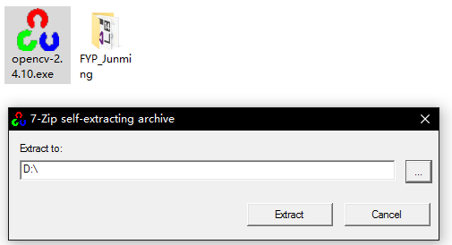

Figure 25. The configuration step 1 of OpenCV

Step 2:

And then go to hard disk D, open the bin folder followed by clicking D:\opencv\build\x64\vc10\bin, finally copy all files in this folder to system folder at

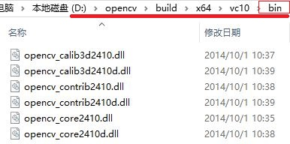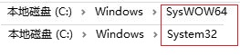

Figure 26. The configuration step 2 of OpenCV

Step 3:

After that, open the project file Junming_Zhang_FYP.sln with Visual Studio 2015 which is shown in Figure 28.

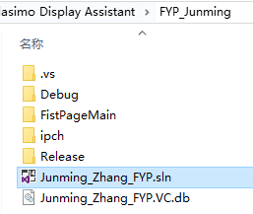

Figure 27. The configuration step 3 of OpenCV

Step 4:

Right click the objective name and then open the properites setting which is shown in Figure 28.

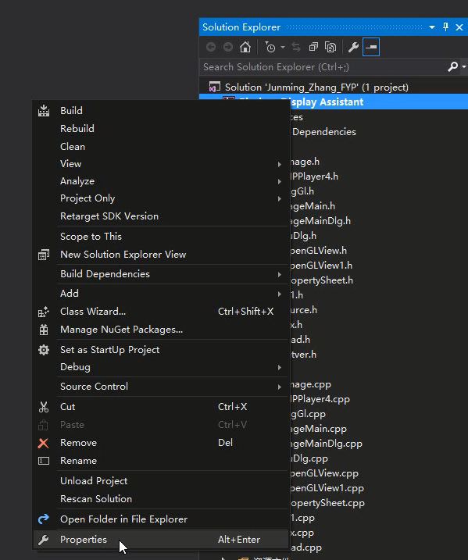

Figure 28. The configuration step 4 of OpenCV

Step 5:

Find the Include Directories of VC++ Directories in the Configuration Properties and then type the following address into it which is shown in Figure 29 and 30.

D:\opencv\build\include\opencv

D:\opencv\build\include\opencv2

D:\opencv\build\include

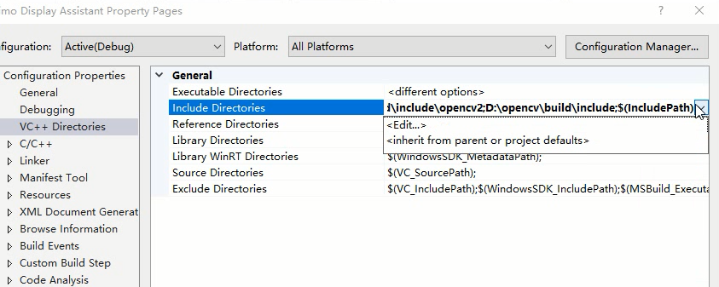

Figure 29. The configuration step 5 of OpenCV

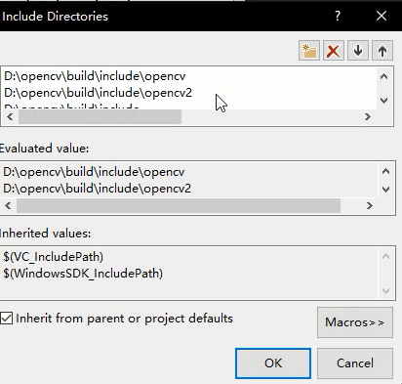

Figure 30. The configuration step 5 of OpenCV

Step 6:

It is similar to the previous step, find the Library Directories of VC++ Directories in the Configuration Properties and then type the following address into it which is shown in Figure 31 and 32.

D:\opencv\build\x86\vc10\lib

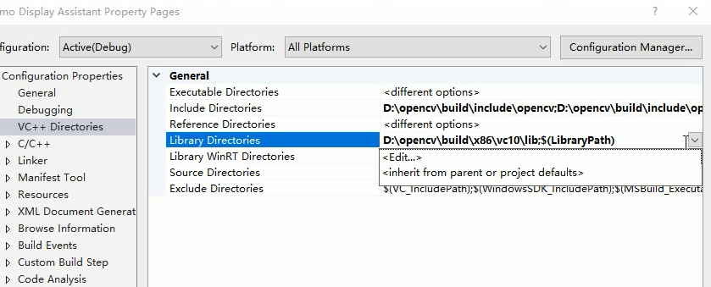

Figure 31. The configuration step 6 of OpenCV

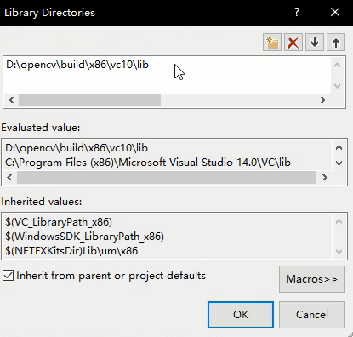

Figure 32. The configuration step 6 of OpenCV

Step 7:

The last step is find the Additional Dependencies of Input in the Linker and then type the following names of library file into it which is shown in Figure 33 and 34.

opencv_ml2410d.lib  
opencv_calib3d2410d.lib  
opencv_contrib2410d.lib  
opencv_core2410d.lib  
opencv_features2d2410d.lib  
opencv_flann2410d.lib  
opencv_gpu2410d.lib  
opencv_highgui2410d.lib  
opencv_imgproc2410d.lib  
opencv_legacy2410d.lib  
opencv_objdetect2410d.lib  
opencv_ts2410d.lib  
opencv_video2410d.lib  
opencv_nonfree2410d.lib  
opencv_ocl2410d.lib  
opencv_photo2410d.lib  
opencv_stitching2410d.lib  
opencv_superres2410d.lib  
opencv_videostab2410d.lib  
opencv_objdetect2410.lib  
opencv_ts2410.lib  
opencv_video2410.lib  
opencv_nonfree2410.lib  
opencv_ocl2410.lib  
opencv_photo2410.lib  
opencv_stitching2410.lib  
opencv_superres2410.lib  
opencv_videostab2410.lib  
opencv_calib3d2410.lib  
opencv_contrib2410.lib  
opencv_core2410.lib  
opencv_features2d2410.lib  
opencv_flann2410.lib  
opencv_gpu2410.lib  
opencv_highgui2410.lib  
opencv_imgproc2410.lib  
opencv_legacy2410.lib  
opencv_ml2410.lib

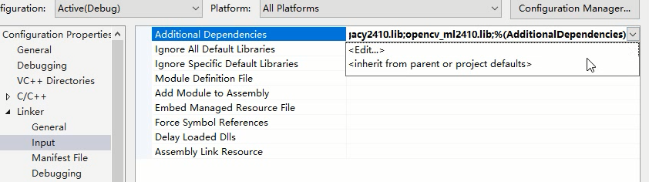 Figure 33. The configuration step 7 of OpenCV

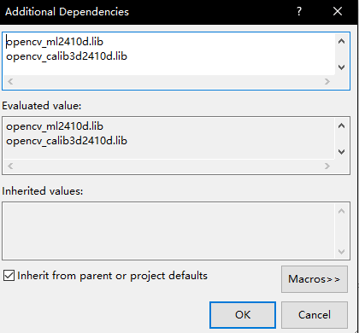

Figure 34. The configuration step 7 of OpenCV

The program can be built now by Visual Studio 2015. Click Local Windows Debugger to obtain the executable program which is shown in Figure 34.



Figure 35. Build process of program

## 6.2 Interface demonstration

The program can be opened after build in the Visual Studio 2015. The executive program is located on the debug folder which is shown in Figure 36.

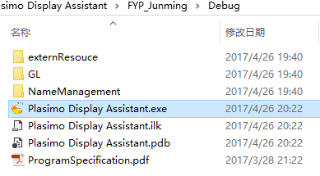

Figure 36. The executive program of this project

Homepage:

The colour of tittle will keep the same with the computer theme. This little function let the program looking more appropriate on the desktop.

The first page display the information of author, supervisor and assessor. Users could learn how to use the program by clicking the page turning button, the following instruction will be displayed on the homepage which is shown in Figure 36, 37 and 38.

The bulb button is help button, it will open the program specification to teach user how to process normal problem and do modification of this program.

The QR code is linked to the Google+ virtual logbook of this program, all developing process will upload to the blog after submit this report.

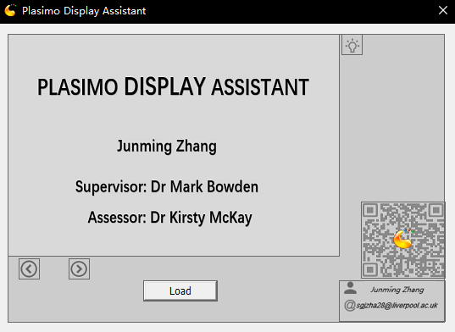

Figure 37. The first page of homepage

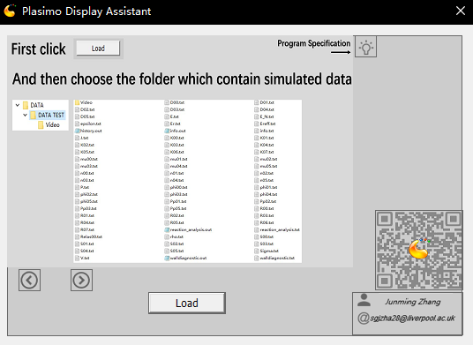

Figure 38. The second page of homepage

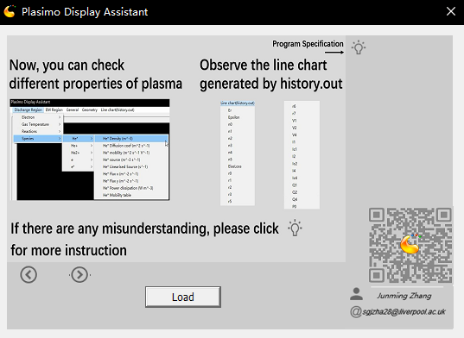

Figure 39. The third page of homepage

Load output file from Plasimo:

The output data of Plasimo can be put in one folder, when the users choose the address of this folder, this program will load all data into memory. First this program will display the final output result which is stored in the info.out file. This function is shown in Figure 41.

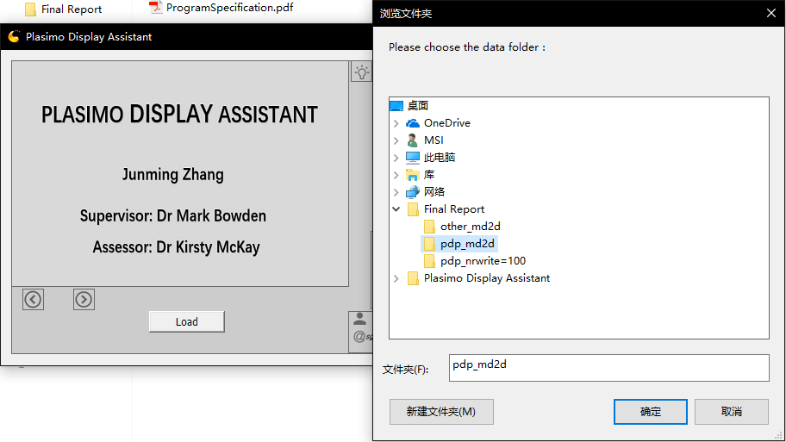

Figure 40. Load the output file into program

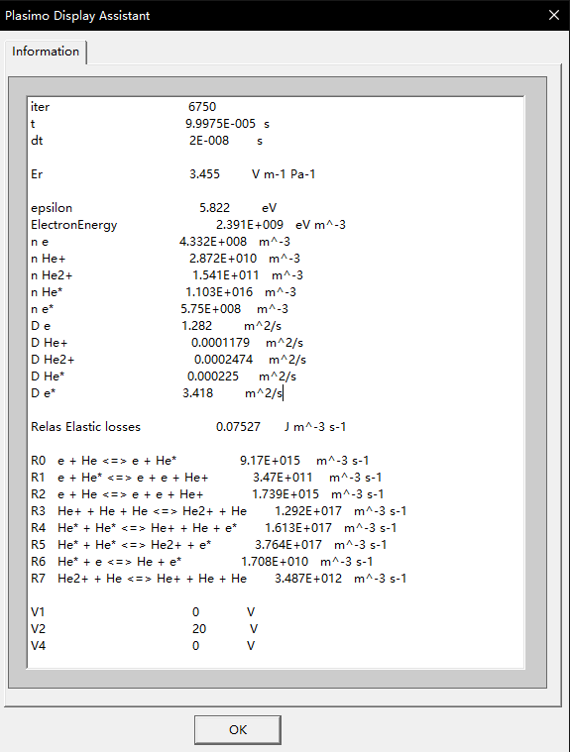

Figure 41. The final output information of input model

Main window of this project:

The main window can be divided into 3 parts. the top area is the menu, left area is the place to display the 2D graphical image, right area is the place to display the numerical data.

The menu is shown in Figure 42, it different from the prototype design because pull-down menu can save the space, it makes the menu combine with the main function areas, therefore the users can operate this program in one window. There are 68 output file of pdp_md2d model, following is the matched result of each properties in menu and output files.

**Discharge Region**

*Electron energy*

|  |  |
| --- | --- |
| Mean energy (J) | epsilon.txt |
| Mean energy density (J/m^3) | n00.txt |
| Elastic energy losses (W/m^3) | No match |
| Elastic energy linearised losses (1/m^3s) | No match |
| Mean energy source (W/m^3) | S00.txt |
| Mean energy linearised source (W) | No match |
| Mean energy flux density (x) (W/m^2) | phi00.txt #x-components |
| Mean energy flux density (y) (W/m^2) | phi00.txt #y-components |
| Reduced field (E/p) | Er.txt |
| Reduced field (E/N) | E_N.txt |
| Energy table | No match |
| Elastic loss table | No match |

*Gas Temperature*

|  |  |
| --- | --- |
| Gas temperature (K) | No match |

*Reactions*

|  |  |
| --- | --- |
| e + He <=> e + He* (Rate) | R00.txt |
| e + He <=> e + He* (Rate coefficient table) | K00.txt |
| e + He* <=> e + e + He+ (Rate) | R01.txt |
| e + He* <=> e + e + He+ (Rate coefficient table) | K01.txt |
| e + He <=> e + e + He+ (Rate) | R02.txt |
| e + He <=> e + e + He+ (Rate coefficient table) | K02.txt |
| He+ + He + He <=> He2+ + He (Rate) | R03.txt |
| He+ + He + He <=> He2+ + He (Rate coefficient table) | K03.txt |
| He* + He* <=> He+ + He + e*(Rate) | R04.txt |
| He* + He* <=> He+ + He + e*(Rate coefficient table) | K04.txt |
| He* + He* <=> He2+ + e*(Rate) | R05.txt |
| He* + He* <=> He2+ + e*(Rate coefficient table) | K05.txt |
| He* + e* <=> He + e*(Rate) | R06.txt |
| He* + e* <=> He + e*(Rate coefficient table) | K06.txt |
| He2+ + He <=> He+ + He + He (Rate) | R07.txt |
| He2+ + He <=> He+ + He + He (Rate coefficient table) | K07.txt |

*Species*

*He\**

|  |  |
| --- | --- |
| He* Density (m^-3) | n01.txt |
| He* Diffusion coef (m^2 s^-1) | D01.txt |
| He* mobility (m^2 s^-1 V^-1) | mu01.txt |
| He* source (m^-3 s^-1) | S01.txt |
| He* Linearised Source (s^-1) | No match |
| He* Flux x (m^-2 s^-1) | phi01.txt # x-components |
| He* Flux y (m^-2 s^-1) | phi01.txt #y-components |
| He* Power dissipation (W m^-3) | Pp01.txt |
| He* Mobility table | No match |

*He+*

|  |  |
| --- | --- |
| He+ Density (m^-3) | n02.txt |
| He+ Diffusion coef (m^2 s^-1) | D02.txt |
| He+ mobility (m^2 s^-1 V^-1) | mu02.txt |
| He+ Source (m^-3 s^-1) | S02.txt |
| He+ Linearised Source (s^-1) | No match |
| He+ Flux x (m^-2 s^-1) | phi02.txt # x-components |
| He+ Flux y (m^-2 s^-1) | phi02.txt #y-components |
| He+ Power dissipation (W m^-3) | Pp02.txt |
| He+ Mobility table | No match |

*He2+*

|  |  |
| --- | --- |
| He2+ Density (m^-3) | n03.txt |
| He2+ Diffusion coef (m^2 s^-1) | D03.txt |
| He2+ mobility (m^2 s^-1 V^-1) | mu03.txt |
| He2+ Source (m^-3 s^-1) | S03.txt |
| He2+ Linearised Source (s^-1) | No match |
| He2+ Flux x (m^-2 s^-1) | phi03.txt # x-components |
| He2+ Flux y (m^-2 s^-1) | phi03.txt #y-components |
| He2+ Power dissipation (W m^-3) | Pp03.txt |
| He2+ Mobility table | No match |

*e*

|  |  |
| --- | --- |
| e Density (m^-3) | n04.txt |
| e Diffusion coef (m^2 s^-1) | D04.txt |
| e mobility (m^2 s^-1 V^-1) | mu04.txt |
| e Source (m^-3 s^-1) | S04.txt |
| e Linearised Source (s^-1) | No match |
| e Flux x (m^-2 s^-1) | phi04.txt # x-components |
| e Flux y (m^-2 s^-1) | phi04.txt #y-components |
| e Power dissipation (W m^-3) | Pp04.txt |
| e Mobility table | No match |

*e\**

|  |  |
| --- | --- |
| e* Density (m^-3) | n05.txt |
| e* Diffusion coef (m^2 s^-1) | D05.txt |
| e* mobility (m^2 s^-1 V^-1) | mu05.txt |
| e* Source (m^-3 s^-1) | S05.txt |
| e* Linearised Source (s^-1) | No match |
| e* Flux x (m^-2 s^-1) | phi05.txt # x-components |
| e* Flux y (m^-2 s^-1) | phi05.txt #y-components |
| e* Power dissipation (W m^-3) | Pp05.txt |
| e* Mobility table | No match |

**EM Region**

|  |  |
| --- | --- |
| Potential (V) | V.txt |
| Current density (C/m^3s) | J.txt |
| Ex (V/m) | E.txt # x-components |
| Ey (V/m) | E.txt # y-components |
| Power Dissipation (W m^-3) | P.txt |
| V_electrode(t) | No match |
| Volume charge Density | rho.txt |
| Surface Charge Density | Sigma.txt |

**General**

|  |  |
| --- | --- |
| Common data | info.out |

**Geometry**

|  |  |
| --- | --- |
| Configuration | No match |
| CV volumes | No match |
| CV areas (ew) | No match |
| CV areas (ns) | No match |

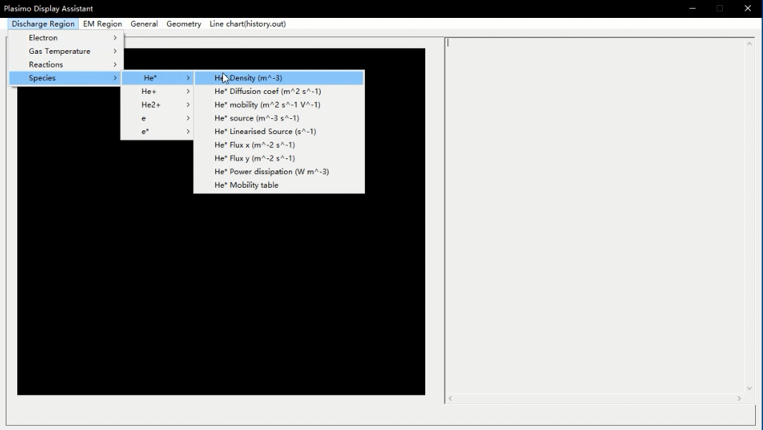

Figure 41. The main window of program and pull-down menu

2D graphic image and numerical data display:

The numerical data will be displayed on the right of main window. The 2D graphic image will be generated based on these data. Data in one period is corresponding to one image, the 2D graphic image will be divided to 7 different intervals with different colours and the digital range will be generated based on the output data. The time and each interval are put on the left side of 2D graphic image. Users could observe the state of plasma in specific time with numerical data at the same time. Figure 42 is the demonstration of these two function.

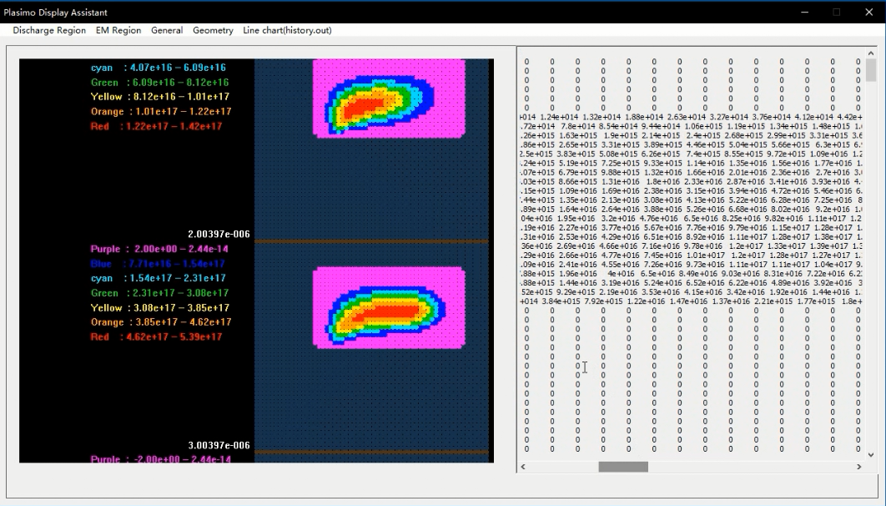

Figure 42. The 2D graphical image with digital number

Line chart based on data in history.out:

User usually check the data in history.out. A line chart function is used to help them observe the output data conveniently. This menu is on the rightmost side of main menu. The time which is the first column data in history.out is used to generate the x axis and the numerical data of each propriety is used to generate the y axis. The scale of axis will automatic generate. The line chart function is shown in Figure 44.

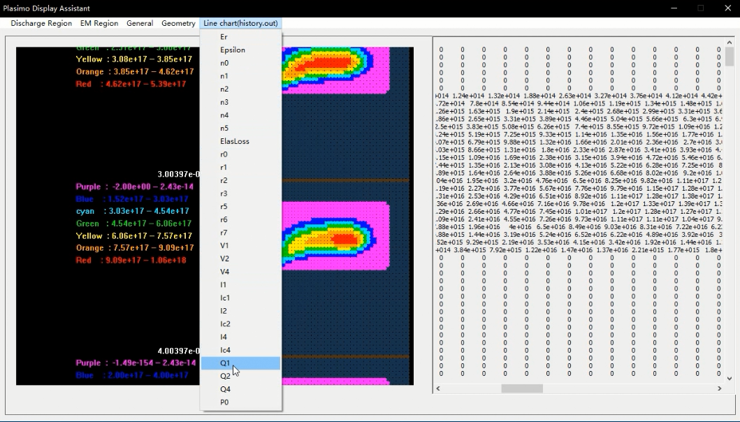

Figure 43. The line chart menu

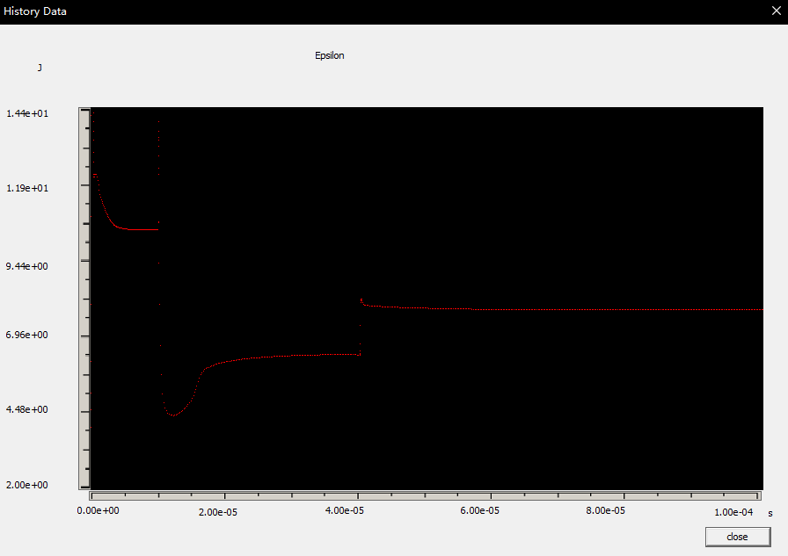

Figure 44. The line chart function

# 7. Industrial Relevance and Impact

There are lots of charged particles in plasma which let it has different characteristics with other normal gas:

* High electrical conductivity and electromagnetic coupling.
* Consists of different particles and high interaction force between them.
* Surface Plasmon Polariton

The basic principle of the plasma is the interaction in charge particles under the influence of electric field and magnetic field. A variety of applications can be achieved by using these characteristics.

For example, low-temperature plasma sources and gas discharges are found with high value in atmospheric, industrial, astrophysical and domestic [6].

In order to investigate different models of plasma, the most efficient method is using computer program simulate the whole changing process and obtain related data, and then display the useful information with graphical or image. According to the observation of the output data and changing process, the mistake in model or technology can be found in the simulation part. In other words, one simulation is equal to one virtual experiment. Normally real plasma experiment is very expensive. However, the simulation is fast and low cost, users could reduce the unnecessary times of design and experiment. Moreover, the optimization of the technological process could be used to improve the production efficiency.

Plasimo is one of the plasma simulated tool and it is the target in this project. It supports the completed simulation of plasma sources in numerous balanced condition.

Plasimo can be used to do a simulation of lots models of plasma.

These applications are found on the homepage of Plasimo [7]:

* Coaxial Plasma Waveguide: Microwave plasma source for large are deposition, decontamination or passivation of layers.
* Chemical Vapour Deposition: Chemical reduction techniques.
* Surfatron: Microwave surfatron plasma for optical fibre production.
* PCVD: Chemical Vapor Deposition for optical fibre production.
* Transport and radiation in complex LTE mixtures
* Sputtering hollow cathode discharge: Sputtering hollow cathode discharges for metal vapour lasers.
* Cascaded arc: Magnum-PSI plasma for testing of materials for the ITER divertor.
* Microplasmas: Microplasmas for biomedical applications.
* Metal-halide lamp: Colour segregation in the metal-halide lamp.
* ICP torch: An open atmospheric inductively coupled plasma.
* Traditional fluorescent lamp: Traditional fluorescent lamp.
* Compact fluorescent lamp: Ignition of a compact fluorescent lamp.

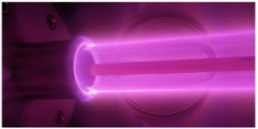

Figure 7. Coaxial Plasma Waveguide

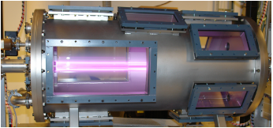

Figure 8. Chemical Vapour Deposition

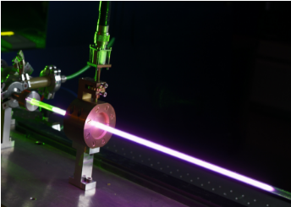

Figure 9. Surfatron

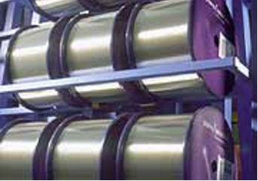

Figure 10. PCVD

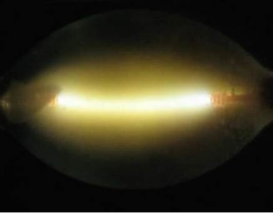

Figure 11. Transport and radiation in complex LTE mixtures

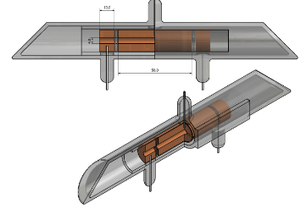

Figure 12. Sputtering hollow cathode discharge

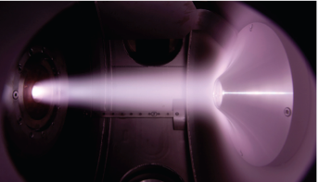

Figure 13. Cascaded arc

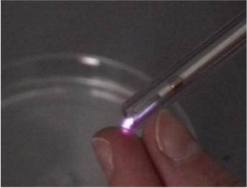

Figure 14. Microplasmas

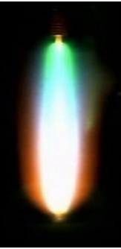 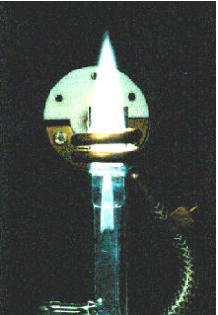

Figure 15. Metal-halide lamp Figure 16. ICP torch

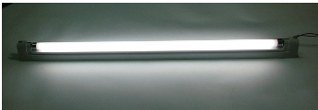

Figure 17. Traditional fluorescent lamp

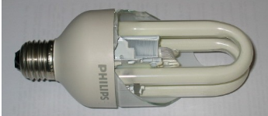

Figure18. Compact fluorescent lamp

In this project, a Plasimo assistant interface is used to process output data from the simulation, which means the advantage of Plasimo will be amplified:

* Figure 19 is the main interface of this project. This program already pre-processed the output data and display them in 2D graphical with different colors. Therefore, users are more convenient to observe the changing process and numerical data.
* Figure 20 is the line chart function of this project. This function supports a basic function which Plasimo users usually use in the normal analysis of each average data in plasma. Therefore, it supports a different way to observe the data and give help to investigate them.

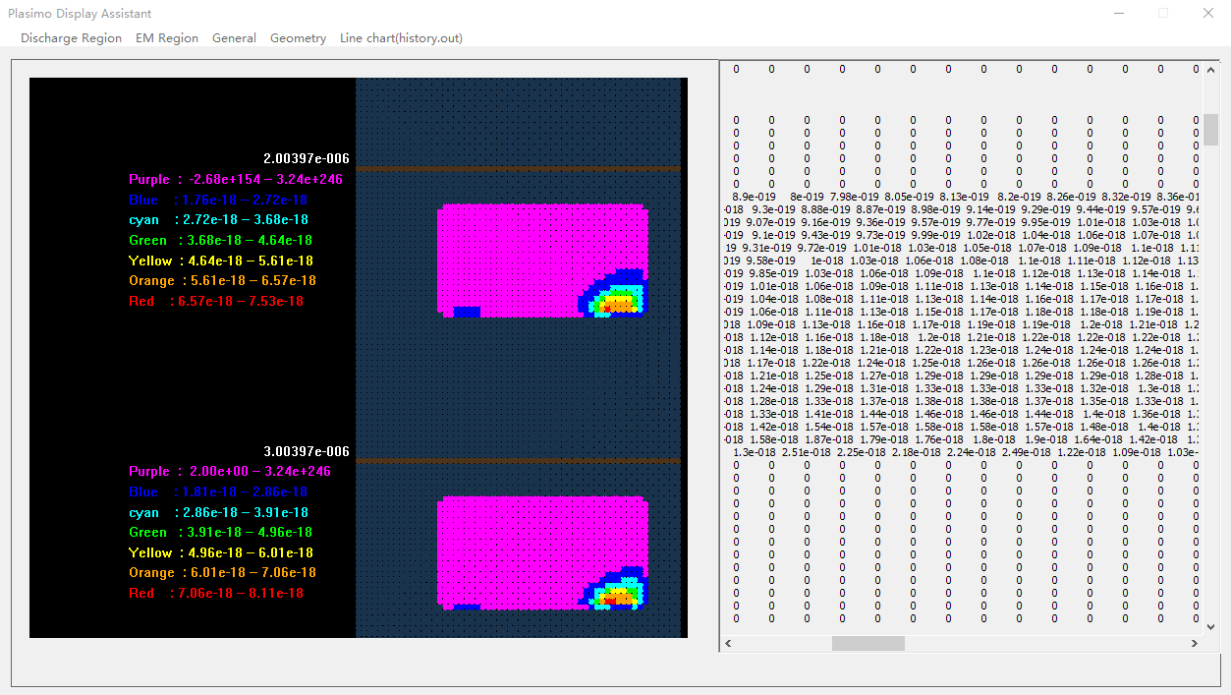

Figure 19. The operation window of Plasimo display assistant

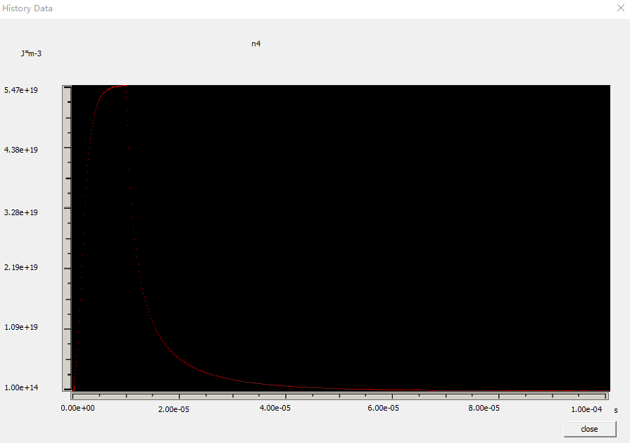

Figure 20. The line chart function of pdp_md2d model of Plasimo display assistant

Figure 21 shows the CO2 emissions situation around the word, the emissions of developing world continues increasing because they keep developing industry. At the same time, the resources depletion is a hard problem for all people. The consumable speed of fuel is more than their regeneration speed.

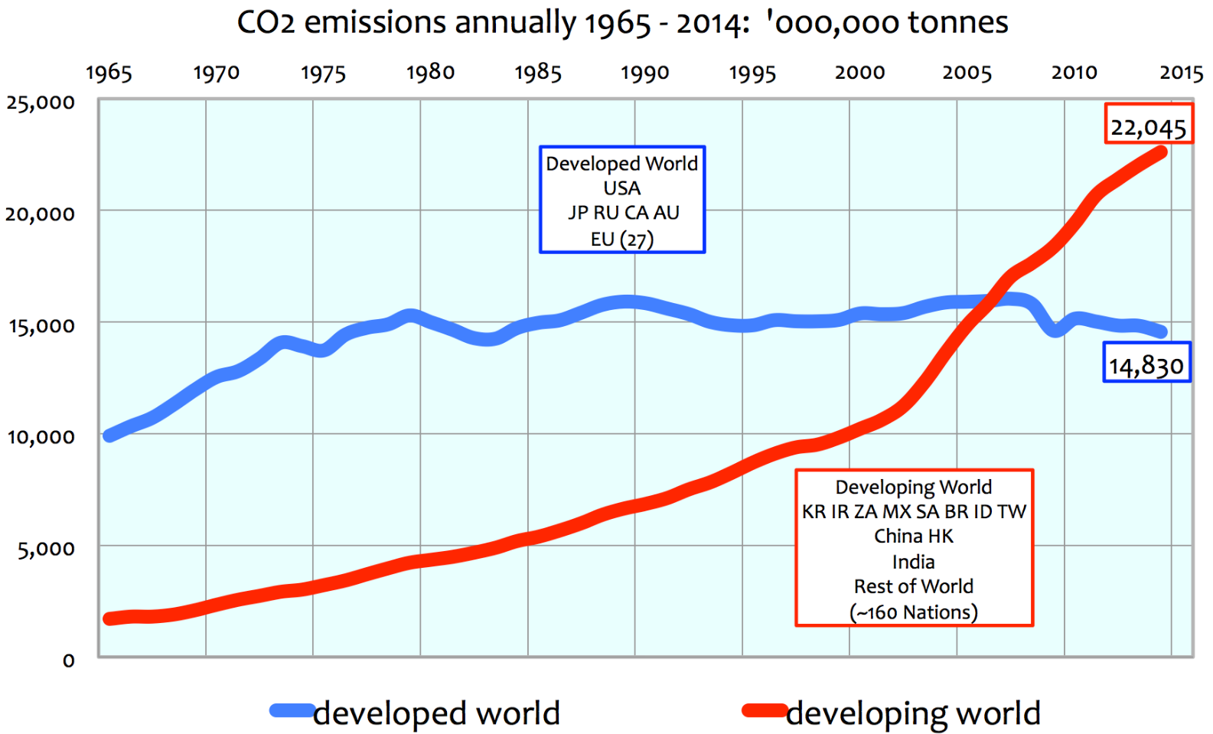

Figure 21. The CO2 emissions line chart of developed and developing countries between 1965-2014 [8]

CO2 emissions and resources depletion can be both solved at the same time by converting CO2 into fuels that can directly replace fossil fuels [9]. A current CO2 model is investigated by Plasimo, it uses the plasma source to obtain oxygen by converting CO2 into CO. However, the modeling process is hard to finish because multiple molecules have lots of different states which make the modeling project complex. This technology will change the world when it comes to success. The social development will achieve a new level because of clean and cyclic energy.

# 8. Discussion

## 8.1 Interface testing

3 output data of Plasimo will be used to test this program. The number of NrWrite control the output information of md2d model, higher NrWrite will generate more data.

* Pdp_md2d model: NrWrite=10 and file size is 32.9MB.
* Pdp_md2d model: NrWrite=100 and file size is 243 MB.
* Other_md2d model: file size is 121MB, in this model, the 2D graphical image almost fill in the space because less 0 and 1 in the output file.

At present, this program can process 150 segment in one text file. But this number can be increased in the MyOpenGLView1.cpp file, change the number followed by the #define maxnum to control the maximum number of periods in one text file. This step is shown in Figure 45.

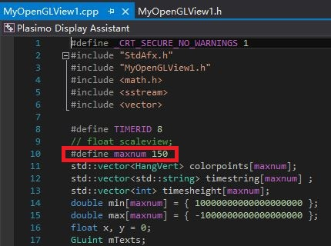

Figure 45. The maximum number of times in one text file setting

Pdp_md2d model with NrWrite 10:

It cost 1.15s to finish the 2D graphical image generation and numerical data display function. It running smoothly in both data and line chart display function. The test result is shown in Figure 46 and 47.

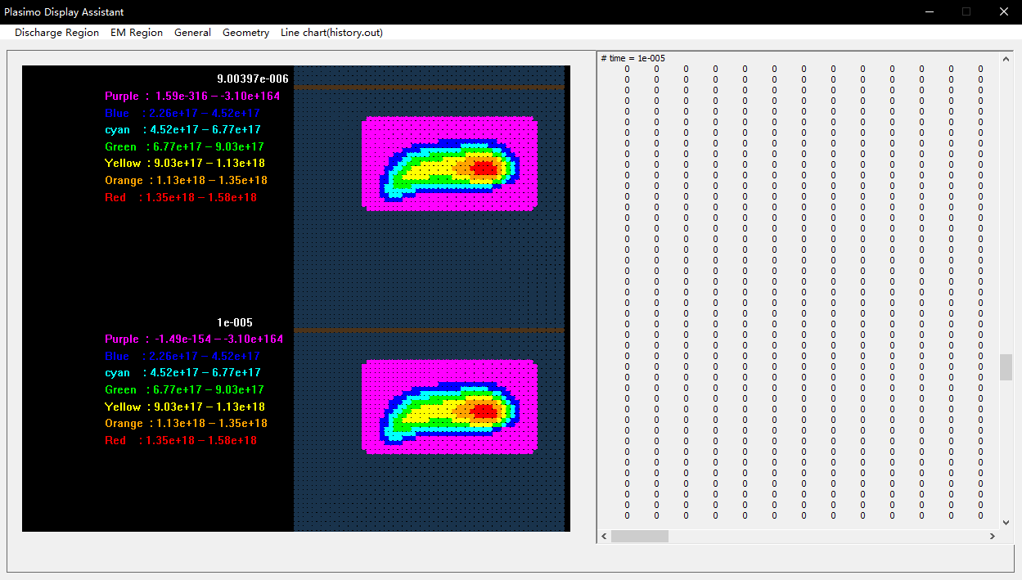

Figure 46. The test result of pdp_md2d model with NrWrite 10 in data display function

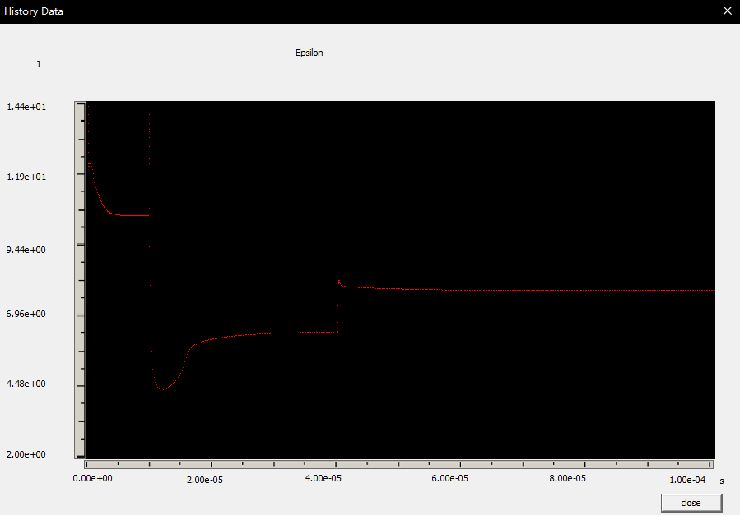

Figure 47. The test result of pdp_md2d model with NrWrite 10 in line chart display function

Pdp_md2d model with NrWrite 100:

It cost 5.23s to finish the 2D graphical image generation and numerical data display function. It running not smoothly as the previous one in the data display part because the input data are 8 times of previous size. The line chart result is same as the previous because they are the same model. The test result is shown in Figure 48 and 49.

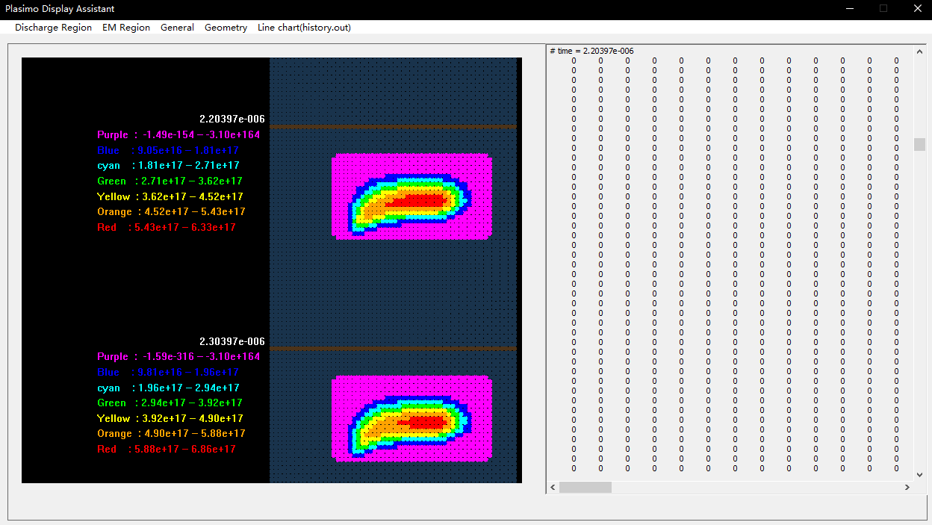

Figure 48. The test result of pdp_md2d model with NrWrite 100 in data display function

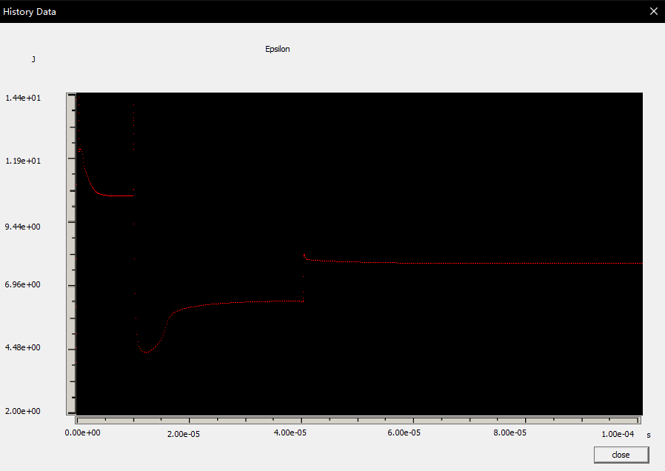

Figure 49. The test result of pdp_md2d model with NrWrite 100 in line chart display function

Other md2d model:

It cost 3.46s to finish the 2D graphical image generation and numerical data display function. It running smoothly in both data and line chart display function. In this model, the output data are not same with pdp_md2d file, therefore the generated image and line chart are different from it which means this program can be applied at related md2d model. The test result is shown in Figure 50 and 51.

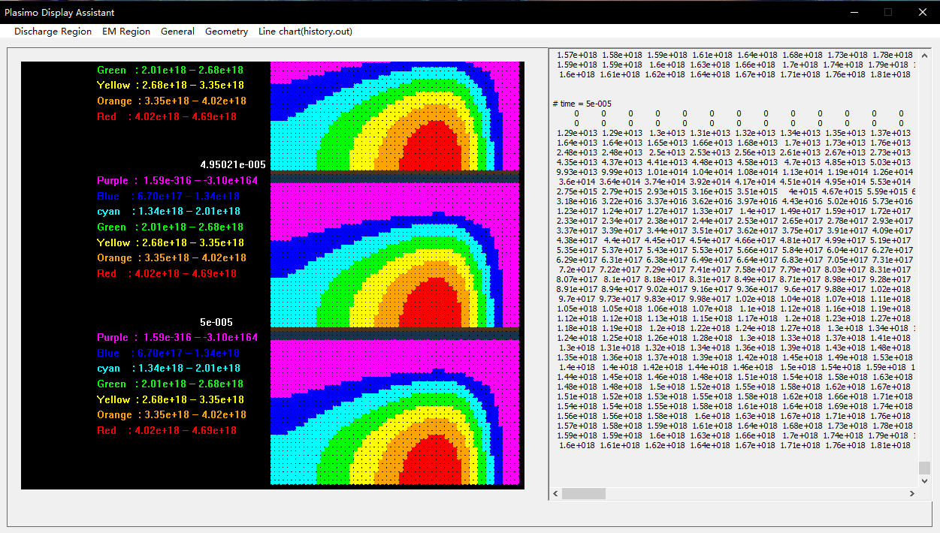

Figure 50. The test result of other md2d model in data display function

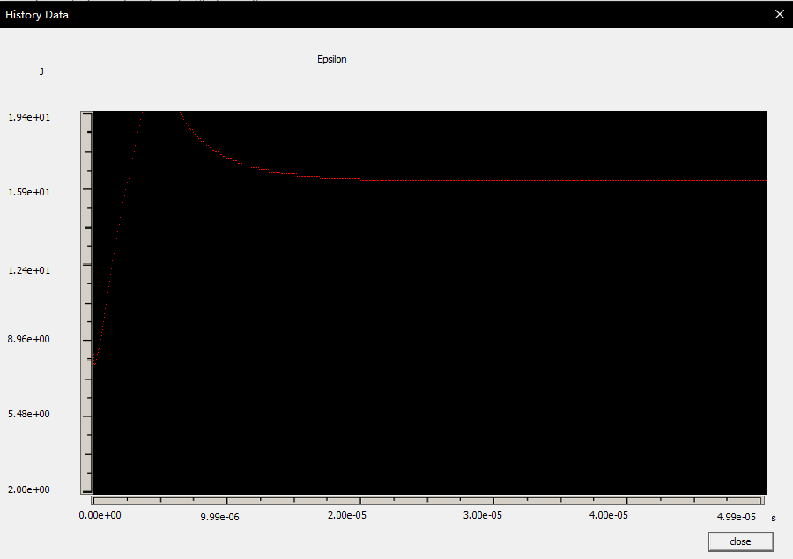

Figure 51. The test result of other md2d model in line chart display function

## 8.2 Project assessment

Achievements:

In Plasimo, the numerical output data are saved in 68 different text files and their name is unreadable, but the developed program matching most text files to corresponding properties. Therefore, the users can find required data easily.

In Plasimo, the simulated process is irreversible and time-consuming, but he developed program can process the output data from Plasimo quickly. For example, Plasimo usually needs 6 minutes to finish one simulation of pdp_md2d model, the developed program only need 1.15s to finish the data processing. Thus, users could observe different properties conveniently.

In Plasimo, users can only observe one property at one time and they cannot obtain the simulated time and numerical data in this dialog box. But the developed program display the numerical data and label the time of 2D graphic image, therefore the users could obtain the information at the same time.

3 models were tested in the previous section. In general, this interface is working successful because compare to the original 3D graphical model in Plasimo, the generated image is almost the same.

Visual Studio is the main developing tool and all code is written by C++ style which is meet the retirement of this project.

Drawbacks:

The processing speed will slow down with the increasing size of input file. In the test section, it cost 5.23s to process 243MB file. In the real-life simulation, some models will generate huge data, this program may become more slow in that case.

The generated 2D graphical images are controlled by the mouse wheel, if the program generated many images, users may need more time to find the image at specific time.

## 8.2 Addition exploitation

In this project, pdp_md2d is the target model, however it is just one model of the Plasimo. According to the investigate of Plasimo, it can be found that different model will generate different files with different name. Therefore, the addition exploitation will focus on the extend function of this project.

The matched result of files and corresponding properties will be stored in a CSV file in the NameManagement folder. For example, pdp_md2d model generate 68 output files, however, there are 87 properties of this model, some output file may lose because the original code of pdp_md2d model limited these files.

The CSV file can quick manage the matching result. Figure 52 display the basic theory of matching. The sub menu is marked by number 1 to 87 because there are 87 properties in pdp_md2d model, The CSV file will store the corresponding text file name based on the number 1 to 87. The CSV reading command will process theses data and use ShowFile command to display required data. ShowFile(0) is corresponding to the first number of CSV and sub menu.

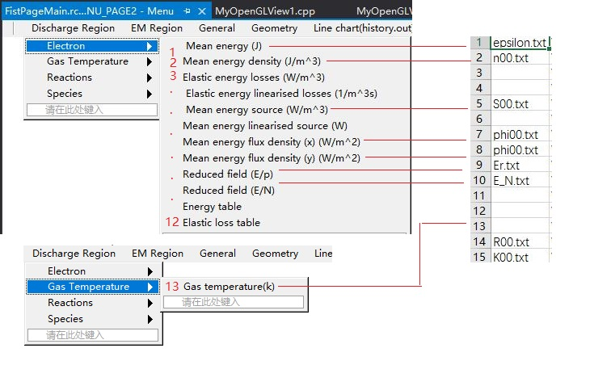

Figure 52. The basic theory of matching data and properties

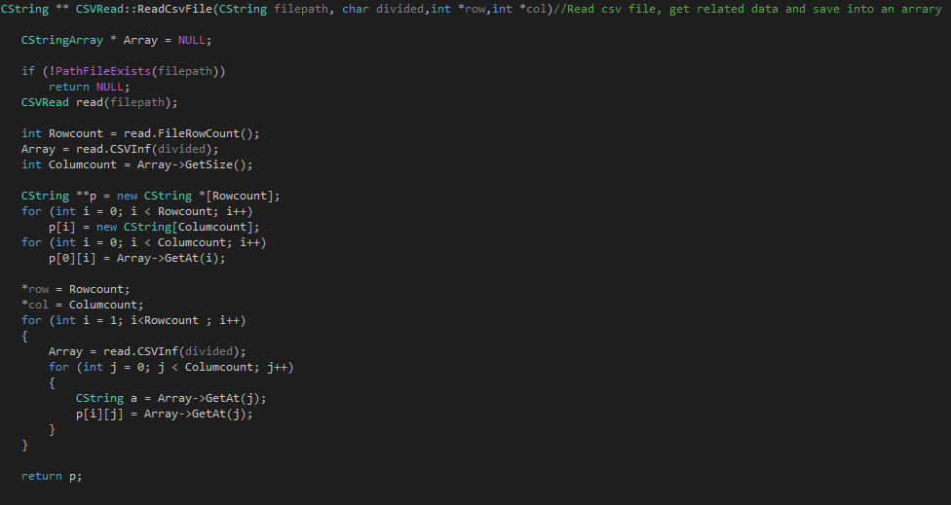

Figure 53. The code of reading csv file function

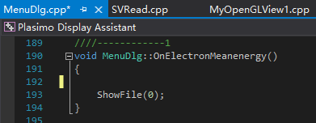

Figure 54. Display corresponding data when click sub-menu

## 8.3 Difficulties

This project has an abandoned version which is using videos and images to display the output data from Plasimo. This interface is shown in Figure 55. It’s inapplicable because it needs lots of time to record videos. For example, it took 8 hours to record 87 videos and images of pdp_md2d model.

It means two interfaces had been developed in 20 weeks, therefore the time limitation is one difficult problem. Cost more time per one week is the solution of this problem.

The unfamiliar object is another dilemma. Plasma is a new area of Electrical and Electronic Engineering undergraduate. To understand the real requirements of plasma researcher, it need more time to think. In addition, C++ and OpenGL code is almost a new area because the fundamental knowledge of C++ was learned in Year 1 but this project need more tanning to achieve the objective.

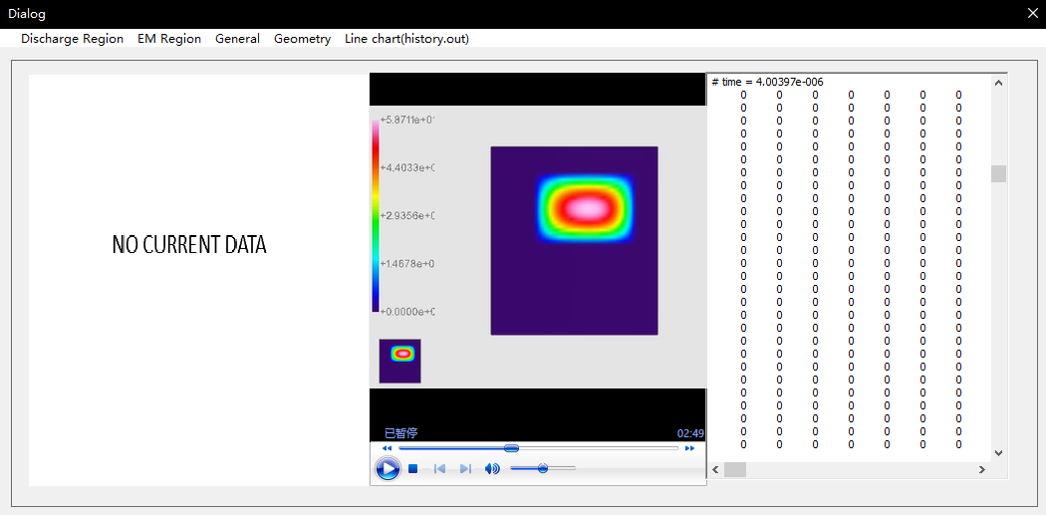

Figure 55. The video version of project

## 8.4 Future Improvements

In the prototype design, there was a quick menu, users could add frequently-used properties in this menu because some properties are useless to research. However due to the time limitation, this function cannot realize.

As mentioned in the project assessment section, the processing speed of this program will slow down with the increasing size of input file and the generated 2D graphical images are controlled by the mouse wheel.

Therefore, the future improvement is redevelopment the program, add the quick menu function and 2D graphical image located based on special time function. At the same time, optimizing the processing speed of input data.

# 9. Conclusion

In general, this preliminary report is the initial guide of the Final Year Project which is the development of a C++ based user-interface for a plasma simulation tool. It has been divided into six parts include the project description, methodology, relevant plan, project rationale, literature review and the result. The aim and objective are developing a user-friendly interface to help researchers and industry users to investigate plasma effectively.

The ability to formulate a project plan and preliminary work are trained through this process. After complete this report, the understanding of the project will increase, so that it will provide convenience to the future development. However, it is still the beginning of this FYP, the details about interface design and corresponding programming still need more time to develop.

# References List

[1] <https://plasimo.phys.tue.nl/plasimo_overview.html>

[2] The Plasimo Team. IEEE Citation Reference [online]. Available: <https://plasimo.phys.tue.nl/physics/md2d/index.html> (accessed 14th October 2016)

[3] The Plasimo Team. (2014 April) IEEE Citation Reference [online]. Available: <https://plasimo.phys.tue.nl/generated-docs/plasimo-5.0.0/misc-docs/user_guide.pdf> (accessed 14th October 2016)

[4] preliminary report

[5] preliminary report

[6] <http://aip.scitation.org.liverpool.idm.oclc.org/doi/pdf/10.1063/1.3141691>

[7]

[8] <http://euanmearns.com/the-record-of-recent-man-made-co2-emissions-1965-2014/>

[9] <https://plasimo.phys.tue.nl/applications/globalmodels/index.html>

[10] B. Shneiderman. (2010) IEEE Citation Reference [online]. Available: <https://www.cs.umd.edu/users/ben/goldenrules.html> (accessed 14th October 2016)

[11]

[12]

[13]

[2] D. Molkentin, “*The Book of Qt 4: The Art of Building Qt Applications*”. San Francisco, USA: No Starch Press, 2007, ISBN-13 978-1593271473

[3] B. Shneiderman. (2010) IEEE Citation Reference [online]. Available: <https://www.cs.umd.edu/users/ben/goldenrules.html> (accessed 14th October 2016)

[4] W.J.M. Brok, M.D. Bowden, J. van Dijk, J.J.A.M. van der Mullen and G.M.W. Kroesen., " Numerical description of discharge characteristics of the plasma needle", *J. Appl. Phys.* vol. 98, 2005, DOI: 10.1063/1.1944218

# Appendices

## Appendix 1. The specification report form

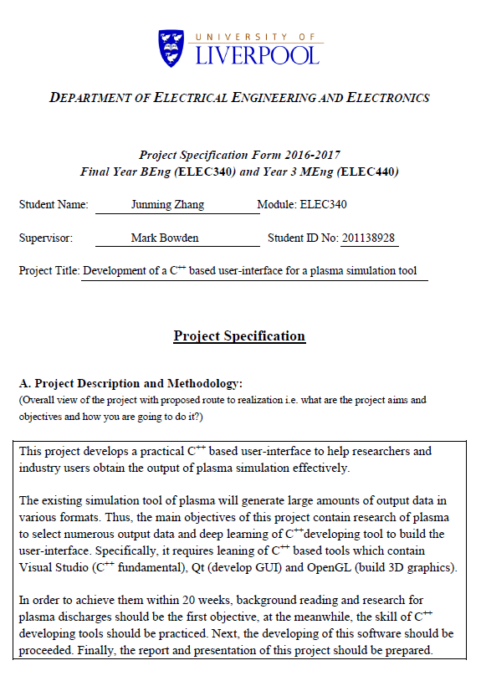

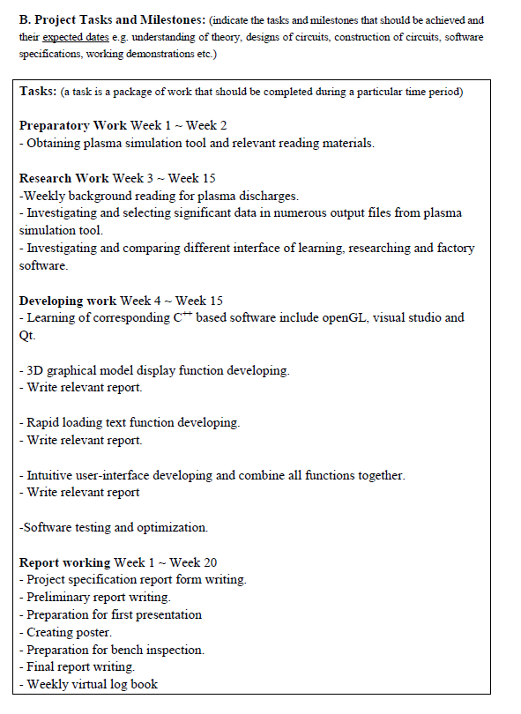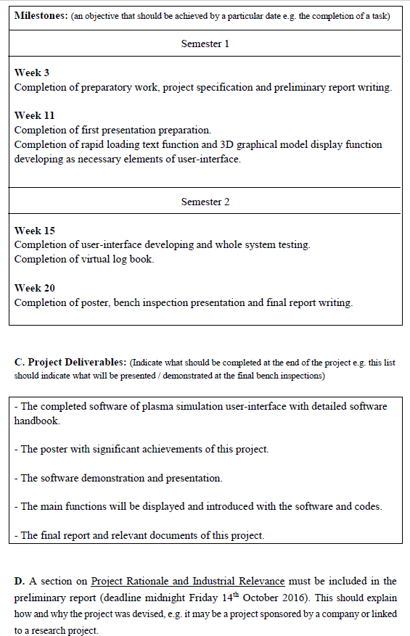

## Appendix 2. A Gantt chart preferable produced by MS project

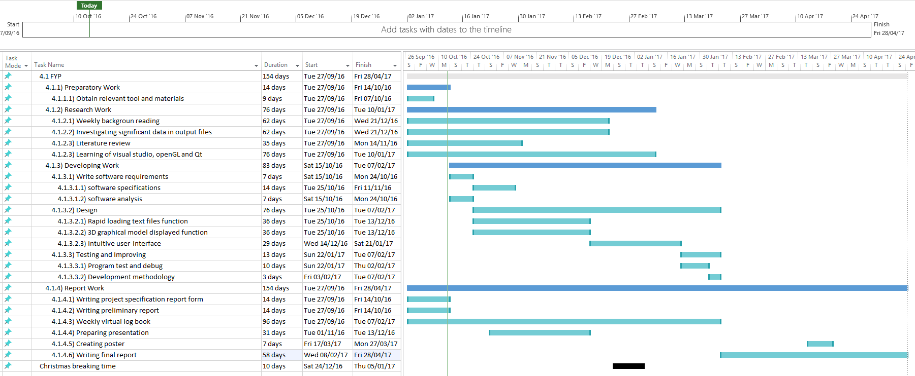

## Appendix 3. The risk assessment form

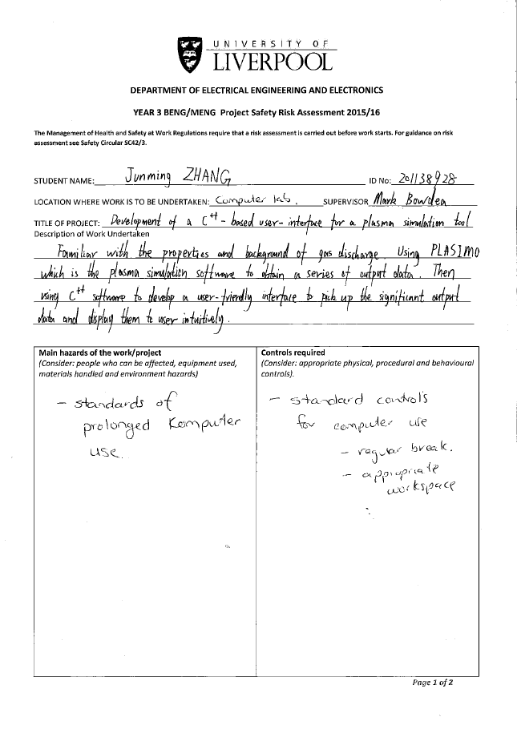

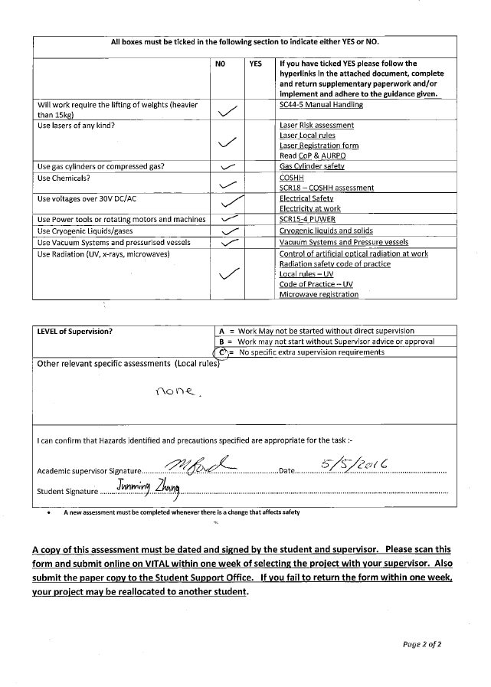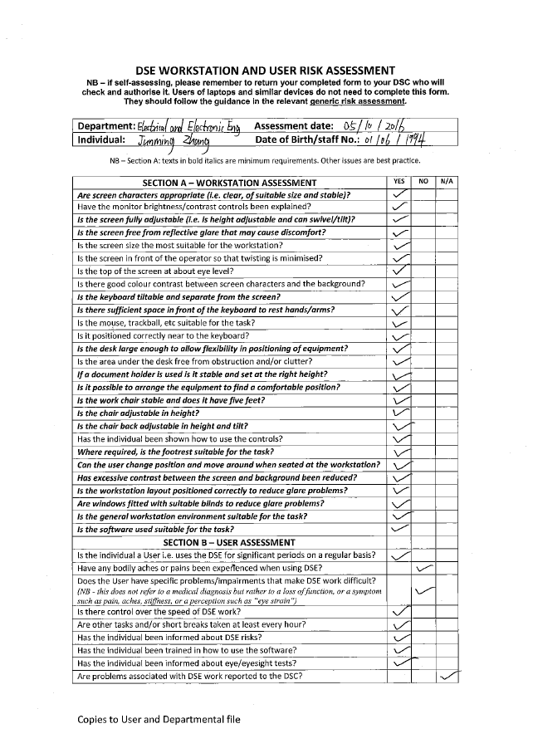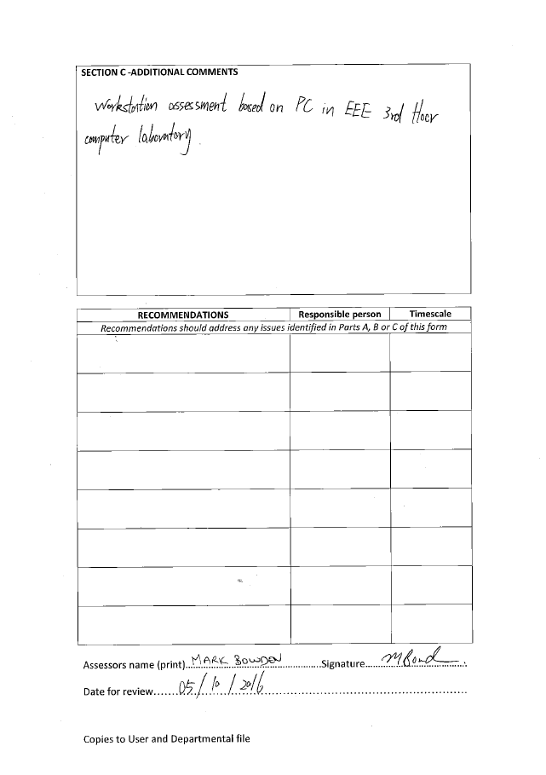

## Appendix 4. Ethical approval questionnaire

